Huiwen Chen ID: 02156341 uniquename:huiwenc

**STAT 500 HW6**

Using the trees data, fit a model with Volume as the response and Girth and Height as predictors.

1. Use the Box-Cox method to determine the best transformation on the response. Compare the fits with and without the transformation.

**Code:**

> g1 <- lm(Volume~ Girth + Height)

> boxcox(g1, plotit =T)

> boxcox(g1, lambda = seq(0.0, 0.6, by =0.05))

> g2 <- lm(I(Volume^0.3)~Girth + Height)

> summary(g1)

Coefficients:

Estimate Std. Error t value Pr(>|t|)

(Intercept) -57.9877 8.6382 -6.713 2.75e-07

Girth 4.7082 0.2643 17.816 < 2e-16

Height 0.3393 0.1302 2.607 0.0145

Residual standard error: 3.882 on 28 degrees of freedom

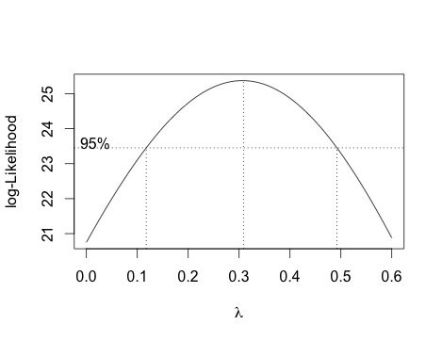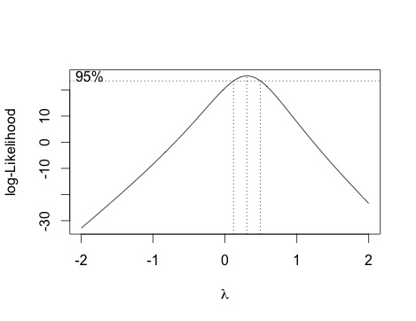Multiple R-squared: 0.948, Adjusted R-squared: 0.9442

F-statistic: 255 on 2 and 28 DF, p-value: < 2.2e-16

boxcox(g2, plotit =T,lambda = seq(0.0, 2, by =0.05))

> summary(g2)

Coefficients:

Estimate Std. Error t value Pr(>|t|)

(Intercept) 0.194613 0.148552 1.310 0.201

Girth 0.121559 0.004545 26.748 < 2e-16

Height 0.011799 0.002238 5.272 1.32e-05

Residual standard error: 0.06676 on 28 degrees of freedom

Multiple R-squared: 0.9775, Adjusted R-squared: 0.9759

F-statistic: 609.1 on 2 and 28 DF, p-value: < 2.2e-16

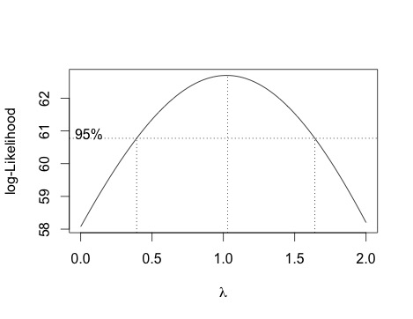

After using Box_Cox method to determine the transformation on the response, it seems like that a cubic root transformation will make a better fit here. Also the new $\hat{λ}$ is close to 1 after making cubic transformation on response. Compare with the fit without transformation, in the fit after transformation the predictor Height becomes more significant and R-squared increases slightly. So the fit after transformations is more acceptable.

1. Try adding higher order polynomial terms in the predictors to the original linear model. Comment on the changes in fit.

Code:

> g3 <- lm(Volume~ Girth+Height+I(Girth*Height)+I(Girth^2)+I(Height^2))

> summary(g3)

Coefficients:

Estimate Std. Error t value Pr(>|t|)

(Intercept) 6.60706 62.90855 0.105 0.9172

Girth -5.12160 2.46674 -2.076 0.0483

Height 0.29491 1.77852 0.166 0.8696

I(Girth * Height) 0.06628 0.05671 1.169 0.2535

I(Girth^2) 0.16393 0.10089 1.625 0.1167

I(Height^2) -0.00494 0.01312 -0.376 0.7097

Residual standard error: 2.655 on 25 degrees of freedom

Multiple R-squared: 0.9783, Adjusted R-squared: 0.9739

F-statistic: 225 on 5 and 25 DF, p-value: < 2.2e-16

> ##remove Height^2

> g4 <- lm(Volume~ Girth+Height+I(Girth*Height)+I(Girth^2))

> summary(g4)

Coefficients:

Estimate Std. Error t value Pr(>|t|)

(Intercept) 26.48906 33.61492 0.788 0.4378

Girth -4.58977 1.98854 -2.308 0.0292

Height -0.32992 0.62857 -0.525 0.6041

I(Girth * Height) 0.0570 0.05024 1.135 0.2668

I(Girth^2 0.17071 0.09762 1.749 0.0921 .

Residual standard error: 2.611 on 26 degrees of freedom

Multiple R-squared: 0.9781, Adjusted R-squared: 0.9748

F-statistic: 290.8 on 4 and 26 DF, p-value: < 2.2e-16

> ##remove Girth^2

> g5 <- lm(Volume~ Girth+Height+I(Girth*Height))

> summary(g5)

Coefficients:

Estimate Std. Error t value Pr(>|t|)

(Intercept) 69.39632 23.83575 2.911 0.00713

Girth 5.85585 1.92134 -3.048 0.00511

Height -1.29708 0.30984 -4.186 0.00027

I(Girth * Height) 0.13465 0.02438 5.524 7.48e-06

Residual standard error: 2.709 on 27 degrees of freedom

Multiple R-squared: 0.9756, Adjusted R-squared: 0.9728

F-statistic: 359.3 on 3 and 27 DF, p-value: < 2.2e-16

After adding all of the quadratic and linear terms of predictor Girth and Height，we find the Height^2 is the highest order term with the largest p-value, so we remove Height^2 and refit. Then remove Girth^2 similarly, and refit again, as a result all of the predictors left are significant with much smaller p-value than before, but the R-squared dropped slightly in the removing process.

3.Try to improve on the best model from (a) by adding higher order polynomial terms in the predictors to the model. Comment on the changes in fit.

> g6 <- lm(I(Volume^0.3)~ Girth+Height+I(Girth*Height)+I(Girth^2)+I(Height^2))

> summary(g6)

Coefficients:

Estimate Std. Error t value Pr(>|t|)

(Intercept)-0.4693099 1.6587938 -0.283 0.7796

Girth 0.1156295 0.0650440 1.778 0.0876 .

Height 0.0305242 0.0468965 0.651 0.5211

I(Girth * Height) 0.0004603 0.0014953 0.308 0.7608

I(Girth^2) -0.0010635 0.0026603 -0.400 0.6927

I(Height^2) -0.0001637 0.0003460 -0.473 0.6403

Residual standard error: 0.07001 on 25 degrees of freedom

Multiple R-squared: 0.9779, Adjusted R-squared: 0.9735

F-statistic: 221.6 on 5 and 25 DF, p-value: < 2.2e-16

> ## remove Girth^2

> g7 <- lm(I(Volume^0.3)~ Girth+Height+I(Girth*Height)+I(Height^2))

> summary(g7)

Coefficients:

Estimate Std. Error t value Pr(>|t|)

(Intercept) -0.6288141 1.5838634 -0.397 0.6946

Girth 0.1259222 0.0587580 2.143 0.0416

Height 0.0332372 0.0456470 0.728 0.4730

I(Girth * Height) -0.0000543 0.0007483 -0.073 0.9427

I(Height^2)-0.0001390 0.0003349 -0.415 0.6815

Residual standard error: 0.06887 on 26 degrees of freedom

Multiple R-squared: 0.9778, Adjusted R-squared: 0.9744

F-statistic: 286.2 on 4 and 26 DF, p-value: < 2.2e-16

> ##remove Height^2

> g8 <- lm(I(Volume^0.3)~ Girth+Height+I(Girth*Height))

> summary(g8)

Coefficients:

Estimate Std. Error t value Pr(>|t|)

(Intercept) -0.0214129 0.5967006 -0.036 0.97164

Girth 0.1394738 0.0480984 2.900 0.00734

Height 0.0145742 0.0077566 1.879 0.07109 .

I(Girth * Height) -0.0002284 0.0006103 -0.374 0.71118

---Residual standard error: 0.06781 on 27 degrees of

freedom

Multiple R-squared: 0.9776, Adjusted R-squared: 0.9752

F-statistic: 393.6 on 3 and 27 DF, p-value: < 2.2e-16

> ##remove Girth*Height

> g9 <- lm(I(Volume^0.3)~ Girth+Height)

> summary(g9)

Coefficients:

Estimate Std. Error t value Pr(>|t|)

(Intercept) 0.194613 0.148552 1.310 0.201

Girth 0.121559 0.004545 26.748 < 2e-16

Height 0.011799 0.002238 5.272 1.32e-05

Residual standard error: 0.06676 on 28 degrees of freedom

Multiple R-squared: 0.9775, Adjusted R-squared: 0.9759

F-statistic: 609.1 on 2 and 28 DF, p-value: < 2.2e-16

After adding higher order polynomial terms to the best model, we find almost all of the predictors are not significant, then we remove the most non-significant and highest order term Girth^2. The p-values of left predictors change a little, and Height^2 and Girth*Height are still extremely unsignificant, so we remove Height^2 at first and refit, then find Girth* Height becomes the only unsignificant predictor. So we remove it and all the predictors left are significant. The R-squared is more stable in this removing process. The final model is a linear one.